5.1 test ms
1. (a) energy or heat (1)
to break a covalent bond (1)
averaged over several compounds (1) 3
(b) propane : C3H8(g) + 5O2(g) → 3CO2(g) + 4H2O(g)
propene : C3H6(g) + 4O2(g) → 3CO2(g) + 3H2O(g) (1)
_____________________________________________
overall: C3H8(g) + O2(g) → C3H6(g) + H2O(g)
[Or balanced cycle (1)]
ΔH = = –2102 + 1977 (1)
= –125 kJ mol–1 (1) 3
(c) Bonds broken 2 × (C – C) + 8 × (C – H) + (O = O)
or nett : 1 × (C – C) + 2 × (C – H) + (O = O) (1)
Bonds formed 1 × (C – C) + 6 × (C – H) + 1 × (C = C) + 2 × (O – H)
or nett : 1 × (C=C) + 2 × (O – H) (1)

Bond enthalpy of O=O ΔH = ΣB(bonds broken) – ΣB(bonds formed) (1)
∴ –125 = B(C – C) + 2B(C – H) + B(O = O) – B(C = C) – 2B(O – H)
∴ B(O = O) = 2(–125 –348 –2 × 413 + 612 + 2 × 463
= +2 × 239 = 478 kJ mol–1 (1) 4
[10]

2. (a)
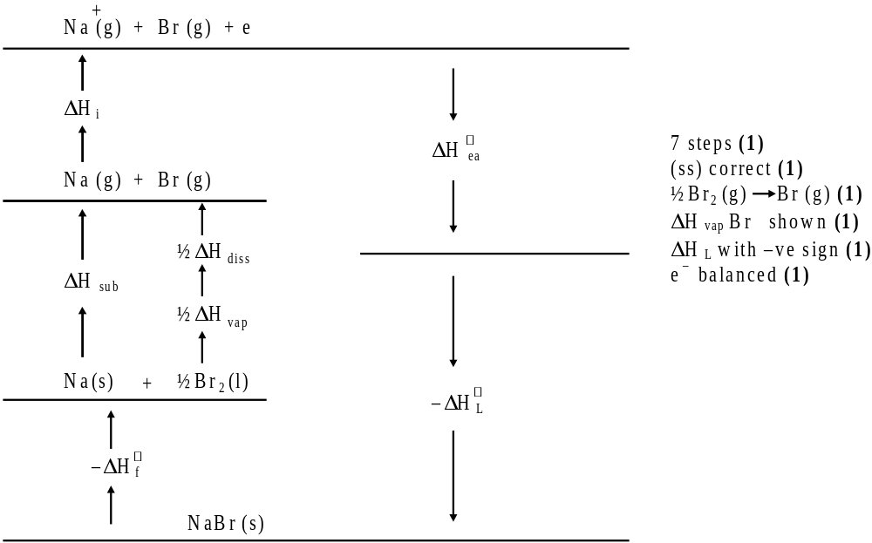
6

(b) –ΔHf + ΔHsub + ΔHi + ½ΔHvap + ½ΔHdiss + ΔHea – ΔHL =O (1)
ΔHvap = 2(ΔHf – ΔHsub – ΔHi – ½ΔHdiss – ΔHea + ΔHL) (1)
= 2 (–361 – 107 – 498 – 97 + 325 + 753)
= +30 kJ mol–1 (1) 3
[9]

3. (i) enthalpy / energy change / energy required / energy evolved
when 1 mol of ionic solid / crystalline solid / crystals / compound
/ solid (not molecules) (is formed from) (1)
its gaseous ions
(must be stated, not transferred by inference from (ii) (1) 2
(ii) Na+(g) + Cl–(g) ® NaCl(s)
allow NaCl(s) ® Na+(g) + Cl–(g) if definition reversed (1) 1
(iii) larger (cations) not atoms, Li, Na (1)
same charge on the cation / ratio of charge:size decreases /
lower charge density not effective nuclear charge (1)
therefore weaker attractions between cation and anion (1)
(must clearly mean attraction between cation and anion) 3
(iv) smaller (cations) not atoms, Mg, Na
allow this mark if ‘repeated error’ from (iii) (1)
greater charge on the Group 2 cation / ratio of charge:
size increases / higher charge density (1)
therefore stronger attractions between cation and anion (1)
(must clearly mean attraction between cation and anion) 3
[9]

4. (i) CaCl2(s) → Ca2+ (aq) + 2Cl- (aq) (1)
Ca2+ (g) + 2Cl– (g) → CaCl2(s) (1)
Ca2+(g) → Ca2+ (aq) (1)
State symbols must be shown
(ii) ΔH/kJ mol–1
CaCl2 (s) → Ca2+ (aq) +2Cl– (aq) –123
Ca2+ (aq) → Ca2+(g) +1650
Ca2+ (g) + 2Cl– (g) → CaCl2 (s) –2255
2Cl– (g) → 2Cl– (aq) –728
ΔHhyd (Cl–(g) = 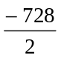 = –364 kJ mol–1
3 equations (3) answer (1)
OR via cycle: 3 steps (3) answer (1) 7
[7]

5. (a) Steam condenses to water when ΔG ≤ 0 (1)
∴ΔH = TΔS (1)
ΔS = 189 – 70 = 119 JK–1 mol–1 (1)
∴ΔH = 373 × 119 = 44 KJ mol–1 (1) 4
(b) spontaneous reaction when ΔG ≤ 0 (1)
CH4(g) + H2O(g) → CO(g) + 3H2(g) (1)
ΔS = 198 + 3 × 131 – 189 – 186 = 216 JK–1 mol–1 (1)
the entropy change in –TΔS (1)
makes ΔG -ve once T is high enough (1) 6
(c) diamond → graphite ΔS = +3 JK–1 mol–1 (1)
since ΔH < 0, ΔG is always < 0 (1)
kinetics: large Ea makes reaction too slow (1) 3
(d) CaO(s) + CO2(g) → CaCO3(s)
ΔS = 90 – 40 – 214 = –164 JK– mol–1 (1)
ΔG = 0, ΔH = TΔS
Ts = 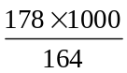 = 1085 K (1) 2
[15]

